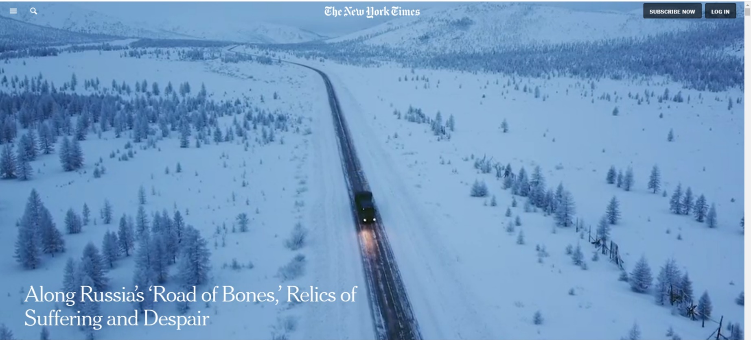
阅读简体中文版閱讀繁體中文版
The Kolyma Highway in the Russian Far East once delivered tens of thousands of prisoners to the work camps of Stalin’s gulag. The ruins of that cruel era are still visible today.
By Andrew Higgins
Photographs and Video by Emile Ducke

The prisoners, hacking their way through insect-infested summer swamps and winter ice fields, brought the road, and the road then brought yet more prisoners, delivering a torrent of slave labor to the gold mines and prison camps of Kolyma, the most frigid and deadly outpost of Stalin’s gulag.
Their path became known as the “road of bones,” a track of gravel, mud and, for much of the year, ice that stretches 1,260 miles west from the Russian port city of Magadan on the Pacific Ocean inland to Yakutsk, the capital of the Yakutia region in eastern Siberia. Snaking across the wilderness of the Russian Far East, it slithers through vistas of harsh, breathtaking beauty dotted with frozen, unmarked graves and the rapidly vanishing traces of labor camps.
There was little traffic when a photographer, Emile Ducke, and I drove last winter along what is now R504 Kolyma Highway, an upgraded version of the prisoner-built road. But a few long-distance trucks and cars still trundled through the barren landscape, oblivious to the remnants of past misery buried in the snow — wooden posts strung with rusty barbed wire, abandoned mine shafts and the broken bricks of former isolation cells.

More than a million prisoners traveled the road, both ordinary convicts and people convicted of political crimes. They included some of Russia’s finest minds — victims of Stalin’s Great Terror like Sergei Korolev, a rocket scientist who survived the ordeal and in 1961 helped put the first man in space. Or Varlam Shalamov, a poet who, after 15 years in the Kolyma camps, concluded, “There are dogs and bears that behave more intelligently and morally than human beings.” His experiences, recorded in his book “Kolyma Tales,” convinced him that “a man becomes a beast in three weeks, given heavy labor, cold, hunger and beatings.”
But for many Russians, including some former prisoners, the horrors of Stalin’s gulag are fading, blurred by the rosy mist of youthful memories and of Russia’s status as a feared superpower before the Soviet Union’s collapse.
Antonina Novosad, a 93-year-old who was arrested as a teenager in western Ukraine and sentenced to 10 years in Kolyma on trumped-up political charges, labored in a tin mine near the “road of bones.” She recalled vividly how a fellow prisoner was shot and killed by a guard for wandering off to pick berries just beyond the barbed wire. Prisoners buried her, Ms. Novosad said, but the corpse was then dragged away by a bear. “This was how we worked, how we lived. God forbid. A camp is a camp.”

Yet she bears Stalin no ill will, and also remembers how prisoners cried when, assembled outside in March 1953 to hear a special announcement, they learned that the tyrant was dead. “Stalin was God,” she said. “How to say it? Stalin wasn’t at fault at all. It was the party and all those people. Stalin just signed.”
A big factor obstructing the preservation of more than just snatches of memory is the steady disappearance of physical evidence of the Kolyma camps, said Rostislav Kuntsevich, a historian who curates an exhibit on the camps at the regional museum in Magadan. “Nature is doing its work, and soon nothing will be left,” he said.
When the snow melts or mining work disturbs the frozen earth, the buried past sometimes still surges to the surface along the road.
Vladimir Naiman, the owner of a gold mine off the Kolyma highway whose father, an ethnic German, and maternal grandfather, a Ukrainian, came to the area as prisoners, stumbled during a thaw into a morass of soggy coffins and bones while working as a geologist in the district of Yagodnoye in the 1970s. Trying to reach gold buried off the road, he had hit a cemetery for prisoners with his bulldozer and got stuck in the charnel for five days.

All of life is connected to the road as hundreds of miles separate settlements and engine trouble can mean freezing to death.

He later put up eight wooden crosses at the site “in memory of those sacrificed.” But as a firm believer that Russia cannot thrive without sacrifice, he today reveres Stalin. “That Stalin was a great man is obvious,” he said, citing the leader’s role in defeating Nazi Germany and in turning a nation of peasants into an industrial power.
Compared with the countless Native Americans killed in the United States, Mr. Naiman said, “nothing really terrible happened here.”
Under President Vladimir V. Putin, memories of Stalin-era persecution have not been erased, as evidenced by a large government-funded Gulag History Museum that opened in Moscow in 2018. But they have frequently been drowned out by celebrations of rival memories, notably of Russia’s triumph under Stalin’s leadership over Hitler in World War II. Rejoicing over that victory, sanctified as a touchstone of national pride, has obscured the gulag’s horrors and raised Stalin’s popularity to its highest level in decades.
At the other end of the country from Magadan, in Karelia next to Finland, the amateur historian Yuri Dmitriev challenged this narrative by digging up the graves of prisoners who were shot by Stalin’s secret police — not, as “patriotic” historians claim, by Finnish soldiers allied with Nazi Germany. In September, he was sentenced to 13 years in prison on the basis of flimsy and, he and his supporters say, fabricated evidence of sexual assault on his adopted daughter.
An opinion poll published in March indicated that 76 percent of Russians have a favorable view of the Soviet Union, with Stalin outpacing all other Soviet leaders in public esteem.
Disturbed by another survey, which found that nearly half of young Russians had never heard of Stalin-era repression, Yuri Dud, a Moscow blogger with a huge youth following, traveled the full length of the “road of bones” in 2018 to explore what he called the “Fatherland of Our Fear.”
After the online release of a video Mr. Dud made about the trip, his travel companion, Mr. Kuntsevich, the Kolyma historian, faced a barrage of abuse and physical threats from die-hard Stalinists and others who resented the past being dredged up.
Mr. Kuntsevich said he had initially tried arguing with his attackers, citing statistics about mass executions and more than 100,000 deaths in the Kolyma camps through starvation and disease. But he quickly gave up.
“It is best not to argue with people about Stalin. Nothing will change their minds,” he said, standing in his museum near a small statue of Shalamov, the writer whose accounts of life in the camps are routinely dismissed by Stalin’s fans as fiction.
Even some officials are appalled by reverence for a murderous dictator. Andrey Kolyadin, who as a Kremlin official was sent to the Far East to serve as deputy governor of the region that covers Kolyma, recalled being horrified when a local man erected a statue of Stalin on his property. Mr. Kolyadin ordered the police to get it taken down.
The coastal city of Magadan, the start of the “road of bones,” commemorates past misery with a large concrete statue called the Mask of Sorrow, erected in the 1990s under President Boris N. Yeltsin. But local rights activists say that the authorities and many residents now mostly want to turn the page on Kolyma’s bleak past.
“Nobody really wants to recognize past sins,” said Sergei M. Raizman, the local representative of the rights group Memorial.
So tenacious is the grip of ever-present but often unspoken horror along the “road of bones” that many of those living in the settlements it spawned, outposts that are now shrinking rapidly and often crumbling into ruins, look back with fondness at what are remembered as better, or at least more secure, times.
About 125 miles out of Magadan, the road reached what would become the town of Atka in the early 1930s, a few years after geologists, engineers and then prisoners began arriving by sea at Magadan, the coastal headquarters of the Far North Construction Trust, an arm of the Soviet secret police and constructor of the Kolyma Highway.
“Our whole life is connected to this road,” Natalia Shevchuk, 66, said in her kitchen in Atka as her gravely ill husband, a former road engineer, lay coughing and groaning in the next room.One of her four sons died in an accident on the road, and she worries constantly about her youngest son, who recently started work as a long-distance truck driver on the highway.
A side road off the main highway leads to Oymyakon, the coldest permanently inhabited settlement in the world. Known as the Pole of Cold, Oymyakon has an average January temperature of minus 58 degrees Fahrenheit (minus 50 degrees Celsius). The coldest recorded temperature there is minus 96 degrees Fahrenheit.
The weather is so forbidding that engine trouble or a flat tire can mean freezing to death, a fate that the authorities have tried to avoid by making it illegal for drivers to pass a stranded vehicle without asking whether its occupants need help.
With hundreds of miles separating the road’s few inhabited settlements, shipping containers fitted with heaters and communication equipment have now been placed in some of the most remote areas so that stricken motorists can warm up and call for help.

Although Atka never hosted a major labor camp, it thrived for years as a result of the gulag, serving as a transport hub and refueling stop for convoys of trucks carrying enslaved workers and supplies to the gold, tin and uranium mines, and to camps filled with the laborers used to repair roads and bridges washed away by avalanches and storms.
When the prison camps closed after Stalin’s death in 1953, Atka kept going, and growing, as forced labor gave way to volunteer workers lured to the area’s mines by the promise of salaries far higher than in the rest of the Soviet Union.
At its peak, the town had more than 5,000 residents, a large modern school, an auto-repair shop, a fuel depot, various stores and a big bakery. Today, it has just six residents, all of them pensioners.
The last school-age resident left with his mother last year. His grandmother stayed behind and runs the only store, a tiny room stacked with groceries on the ground floor of an otherwise empty concrete apartment block.

The natural forces that are wiping out physical traces of the gulag threaten to eliminate Atka, too. Its largely abandoned apartment buildings are rotting away as snow pours in through broken windows, cracked roofs and smashed doors.
Until this year, Atka’s only employer, aside from a truck stop cafe and gas station on the edge of town, was a heating plant. The plant shut down in late September after the district government, which has for years been pushing residents to move to more viable settlements, cut funding.
This left apartments without heat, forcing people to install their own devices to avoid freezing to death. Tap water has also been cut off, leaving residents dependent on deliveries of canisters filled from a well.
Ms. Shevchuk’s building has 30 apartments, but only three are occupied. She relies on a wood-burning stove that she installed in her bathroom to keep warm.
Valentina Zakora, who until recently was Atka’s mayor, said she had tried for years to persuade the few remaining residents to move away. As a relative newcomer — she came to Atka 25 years ago with her husband, a mechanic — she could not understand why people did not want to take up a government offer of money and free housing elsewhere.
“I cried every day for three years when I first saw this place,” she recalled. After raising a family there, she moved away this past spring to a well-maintained town closer to Magadan.
She would like to see Atka survive, but “it is already too late for places like this.”

A Russian Lada car driving along the Kolyma Highway.

Source: https://www.nytimes.com/2020/11/22/world/europe/russia-stalin-gulag-kolyma-magadan.html

