COLONIALISM: POPULATION DIVERSITY IN AUSTRALIA AND INDIA

Britain's colonialism had myriad consequences on its subjects. My brief commentary reflects on its historical and contrasting effects on population diversity in Australia and India.

The Indian political and social refrain is that India's political and cultural diversity is its greatest strength ("Unity in Diversity"). The sheer range of its multi-religious/lingual/caste/political orientations is unmatched in the world. Two maps below, one showing pre-independence territorial/political boundaries, the other linguistic delineations, give an idea of Indian diversity.

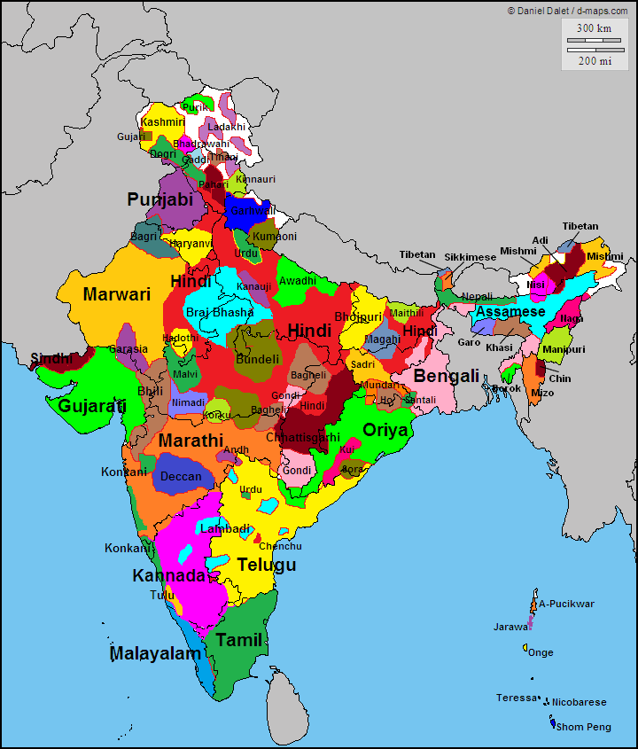

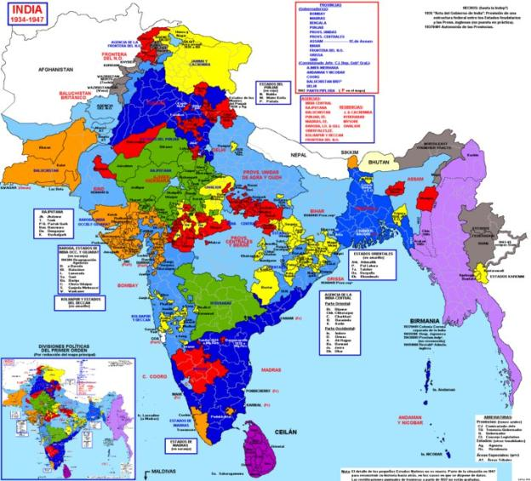

Three hundred years of British colonialism did not dent this diversity. It endured despite people being forced to adopt various civil laws and social dictums (e.g. McCauley's Education edicts), which applied uniformly throughout the land. At the height of Raj, less than 50000 British (white) masters controlled over 300 million (brown) subjects. Faced with sheer numbers of social, economic and political shades in the population, the Brits wisely focused on the 'Divide and Rule' policy. One by-product was to retard any movement towards national homogeneity.

Post-independence, the democratic framework has ensured not only diversity, but it has encouraged multiplicity of growing diverse sectional demands. Ironically, the ruling elites in the Delhi sultanate have used the well-worn colonial divide and rule stratagem to advance their political and economic ideological goals.

Now, contrast this with what happened in Australia.

Lieutenant Cook arrived in Australia in 1770 and against all visible evidence – local tribes watched the landing in Botany Bay - declared Australia as *terra Nullius* ("nobody's land"). In effect, that legally deemed the land to be unoccupied or uninhabited. In turn, that set the ground for the unilateral establishment of Australia as a British Colony when the First Fleet arrived in 1788.

The fact is that the Aboriginal people had been living on the oldest continent for millennia. "It was blackfella country" (Vincent Liangiari, 1966). The estimated Aboriginal population was some 750000. There were some 500 distinct clan groups or nations, each with its language, laws, customs and cultural beliefs. The Australian continent then was the most diverse entity on the planet with the possible exception of the Indian sub-continent. The Australian Institute of Aboriginal and Torres Strait Island Studies (AIATSIS) has produced a map of First Nations, which says it all:

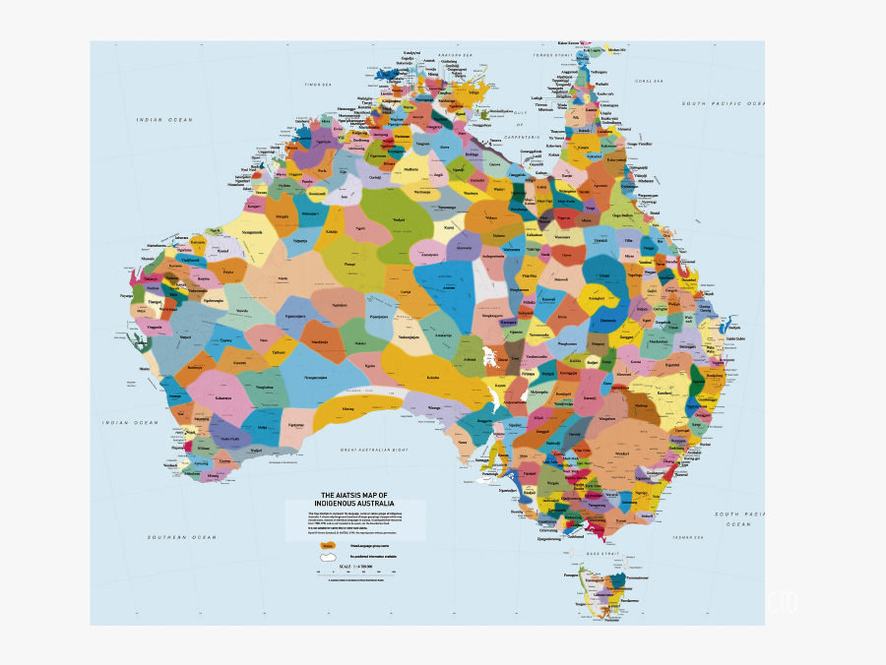

Today, there are some 800000 indigenous First Nation peoples in Australia. It has taken nearly 230 years for the indigenous population to grow back to its size at the time of the original settlement.

The natural growth of the Aboriginal population was offset by what the successive waves of convicts, soldiers and settlers wrought: exotic diseases (e.g. smallpox); mini-genocides; killings of traditional owners of in-lands snatched by white settlers for agriculture; separating children from parents to 'evangelise' and 'civilise' them; popularisation of alcohol; deaths in custody on trivial offences. (Even today, Aboriginals comprise 2% of the population but 28% of those in prison.)

It should be a salutary reminder to those who pride themselves on their ancient civilisational history, mainly Indians and Chinese, that Australian Aboriginals and Torres Strait Islanders are the oldest known surviving culture on the planet.

It is, therefore, to the credit of the Australian polity, indigenous and non-indigenous, that at formal occasions the First Nations people are acknowledged as the original owners of the land. For example, an official speech in Canberra commences with:

'I/We wish to acknowledge the traditional custodians of the land we are meeting on, the Ngunnawal people. I/We wish to acknowledge and respect their continuing culture and the contribution they make to the life of this city and this region.'

Incidentally, it is to the credit of the Indian Prime Minister's Office that stray advice prompted Prime Minister Modi to commence his Address to the Joint Session of the Australian Parliament in November 2014 with the acknowledgement that he was speaking in the land of the Ngunnawal people. That gesture, one of the very first by a visiting Head of Government, earned him much kudos.

Is it not a time for Indian netas and babus to acknowledge the heritage and the continuing value of the tribal people to the making of the Indian nation?

Rakesh Ahuja

3 November 2020