This copy is for your personal, non-commercial use only. To order presentation-ready copies for distribution to your colleagues, clients or customers visit https:// www .djreprints .com.

https :// www.wsj .com/ art icIes/ double-face-mas ks-n95-protect-you rself-against-new-covi d-19-variants-with-these-mask-upgrades-11612473349

**YOUR HEALTH**

**Double Face Masks? N95? Protect Yourself Against New Covid-19 Variants With These Mask Upgrades**

The guidance around masks is changing. Here's the latest that you need to know.

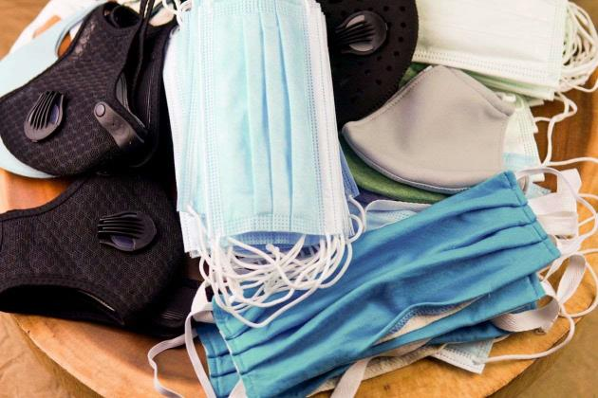

Doctors say it's important to improve the effectiveness of your mask practices now.

**PHOTO:** GETT Y IMAGES

*By*

*Sumathi Reddy*

Updated Feb. 71, 202117:44 am ET

It's time to up your mask game.

As new, more-contagious coronavirus variants circulate, doctors say it's important to improve the effectiveness of your mask practices-such as by "double masking" to wear two at once Numerous studies have found that masks help protect the wearers as well as those around them from the virus that causes Covid-19.

"Now more than ever, the next four to six months are the most critical time to really up your mask," says John Volckens, a professor of mechanical engineering at Colorado State University in Fort Collins, Colo.

But how exactly do you mask better? And what other guidance on masking has changed? Here's what you need to know.

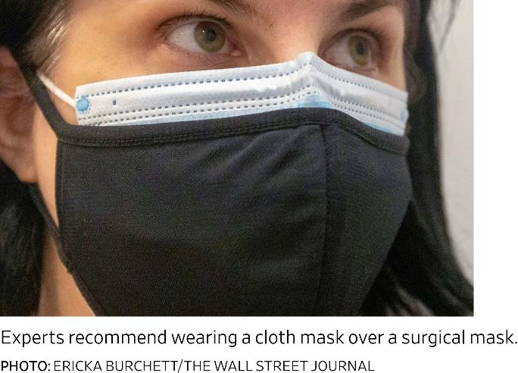

## What is double masking and why are people talking about it?

**What's the best way to double mask?**

Most experts say a cloth mask over a surgical mask is the way to go. A cloth mask can also help when worn over a KF94 mask, which are certified in South Korea to filter at least 94% of very small particles, says Dr. Marr. KF94s can be somewhat loose on the sides, so a cloth mask can help pull it tighter to your face.

A second mask is generally not necessary when wearing an N95, which are certified to filter out at least 95% of very small particles, or a KN95, the Chinese equivalent of an N95. But it could help protect the N95's material and extend its use.

It's important to maintain breathability when double masking, says Dr. Volckens. "If a mask isn't breathable, one of two things happens," he says. "If there's too much resistance the mask will leak, or if it's too uncomfortable you will take it off."

## What about cloth masks with filters?

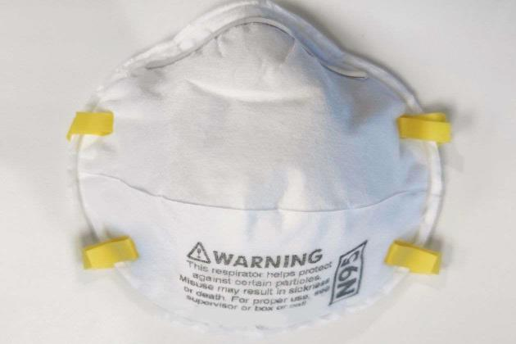

A large filter that fits over your nose and mouth can improve filtration, says Mark Rupp, chief of the division of infectious diseases at the University of Nebraska Medical Center in Omaha. But if the filter is only covering a small area, it's probably not very helpful. He says filters should be replaced when they are damp or soiled. Dr. Volckens recommends masks with a permanent built-in filter.

Numerous studies have found that masks help protect the wearers as well as those around them from the virus that causes Covid-19.

**PHOTO:** GETTY IMAGES

Legitimate N95s can be difficult for regular consumers to find.

The risk level of your setting is important, says Joseph Allen, director of the Healthy Buildings Program at the Harvard T.H. Chan School of Public Health. You probably don't need to wear an N95 if you're going on a walk with a friend or to the playground outside. But if you're working indoors in a restaurant or grocery store, or going to an indoor location with many people, it's a good idea to wear one.

In hospitals, N95s are carefully fitted. So look for leaks around your face, says Rachael Mary Jones, an associate professor in the department of family and preventive medicine at the University of Uta h. "You have to pinch the metal tab at the top of the nose very firmly, to the point where it feels uncomfortable, to get it to conform to the shape of your face," says Dr. Jones.

But if you find tight-fitting N95's unbearably uncomfortable, avoid them, because you are more likely to take them off, says Monica Gandhi, an infectious disease physician and professor of medicine at the University of California, San Francisco.

## What's the difference between a N95, KN95 and KF94? Is one better than the other?

Dr. Allen says a close second to N95s are KF94s, a mask certified in South Korea that American consumers can easily find online. "We can have a lot of confidence in these masks," says Dr. Allen. "They capture 94% of particles and they are a lot more comfortable ."

Another popular option is the KN95 masks, the Chinese equivalent of an N95. But Dr. Allen

# Do I need to he worried about counterfeit N95s, KF94s or surgical masks?

In the U.S., NIOSH certifies the companies that make N95 respirators, which must have an approved label on or within the packaging. If there is no marking or TC number or NIOSH is spelled wrong, that's a red flag.

So far, experts say they're not aware of widespread counterfeiting ofKF94s or standard surgical masks, but it's wise to remain vigilant about labeling.

# How effective are the widely available blue surgical masks?

The filtration of blue surgical masks can vary. Look for ASTM certification on surgical mask boxes. "Those are very good at filtering out aerosols of all sizes," says Dr. Marr. Level two and three are especially good.

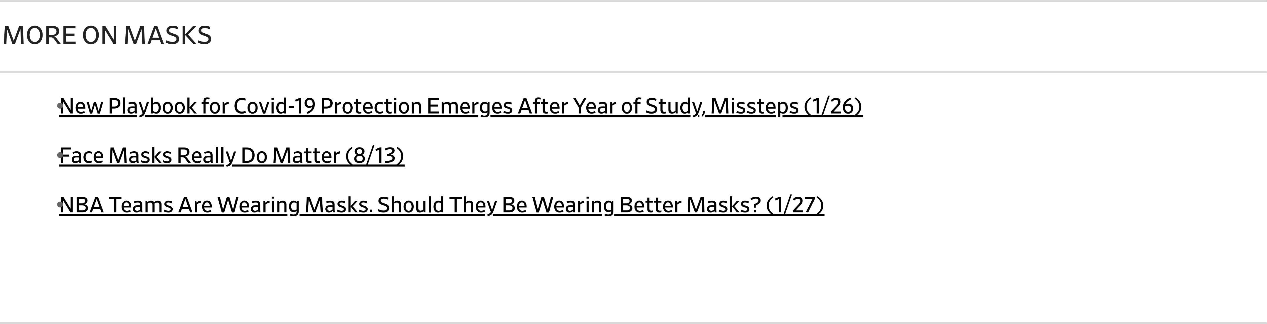The downside of surgical masks is they don't fit snugly on most faces. "It's just a rectangle and you're trying to make it fit to your face, so there are inevitably gaps on the side so they leak like crazy," says Dr. Marr. This is where double masking can be helpful.

# How can I tell if my mask has a good fit?

When you breathe in, the mask should press in or flex into your face with the air flow. You can also breathe out. There should be no gaps of air coming out of the sides of your mask.

If your glasses fog up, that means air is escaping around the top of your mask by the nose bridge, says Dr. Volckens. If you don't wear glasses, put on a pair of sunglasses to see if they fog up.

Another good test: Stand in front of a mirror and breathe out forcefully. Did you blink? If

so, that means air hit your eyelids and is escaping around the mask.

Dr. Marr says mask fitters, though unsightly, can make a big difference and improve the performance of a looser-fitting mask, like a surgical mask.

Metal nose bridges also help improve fit, as do straps around the back of the head, says Dr. Marr. Mask keepers-little clips that attach to ear loops and wrap around your head-are also useful.

**Many of these masks-like N95s, KN95s, KF94s and surgical masks-are supposed to be for a single use, but people often reuse them. How many times can I wear them and how do I store them between uses?**

Some scientists say such masks can be worn until they are visibly soiled or damaged. Dr. Jones says multiple uses won't degrade the filtration; it's the fit that can degrade.

Store single-use masks that you intend to wear again somewhere dry and away from other things, like in a paper bag or open Tupperware, or hang it up somewhere, experts say.

Don't use chemical disinfectants on masks. "If you're spraying chemicals on your mask you're going to be inhaling those chemicals," says Dr. Volckens. And don't wash N95s, because it will damage their electrical filtration ability, he warns.

**What kind of mask should kids wear?**

Dr. Gandhi says there's generally no need for children to double mask. There are smaller sized surgical masks and KF94's that are good for kids, but any well-fitting cloth mask will provide some benefit.

Avoid masks that kids have to tug down a lot. "Comfort is key to this population," says Dr. Gandhi. "Fit should be tight but definitely allow for natural talking."

*Appeared in the February 9, 2021, print edition as 'Mask Strategies to Combat Covid Variants.'*

Copyright © 2021 Dow Jones & Company, Inc. All Rights Reserved

This copy is for your personal, non-commercial use only. To order presentation-ready copies for distribution to your colleagues, clients or customers visit htt ps:// [www.djreprints.com.](http://www.djreprints.com/)