This copy is for your personal, non-commercial use only.To order presentation-ready copies for distribution to your colleagues, clients or customers visit https://[www.djreprints.com.](http://www.djreprints.com/)

https://[www.wsj.com/articles/the-secret-benefits-of-retelling-family-stories-11573468201](http://www.wsj.com/articles/the-secret-benefits-of-retelling-family-stories-11573468201)

WORK & FAMILY

The Secret Benefits of Retelling Family Stories

Children learn about family history and identity through stories told by older generations.

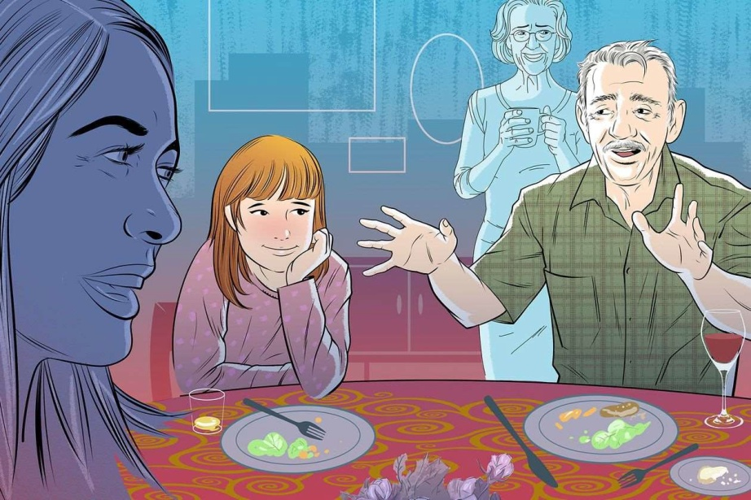

**PHOTO:**DOMINICBUGATTO

*By Sue Shellenbarger*

Nov.71,20195:30 amET

Telling family stories about crazy Uncle Joe or other eccentric relatives is a favorite pastime when families gather for the holidays.But will squirming children or Instagram-obsessed teens bother to listen?

Actually, kids absorb more information from family stories than most adults think. And that knowledge bestows surprising psychological benefits, research shows.

The best holiday stories are funny or entertaining and often convey life lessons, says Robyn Fivush, a psychology professor and director of Emory University's Institute for Liberal Arts. "They have a very important function in teaching children, 'I belong here. I'm part of these stories.' They provide not just a script for life, but a set of values and guide posts,"she says.

Hannah Rose Blakeley, 26 years old, says listening to stories about her late uncle led her to appreciate her family's resourcefulness in the face of adversity. A Vietnam veteran who once worked as a rough neck in rattle snake-infested oil fields, her uncle donned thick leather work boots, wrapped them in burlap, tromped through the grass and captured any rattlers that thrust their fangs into his protective gear. Then he sold them to laboratories, where their venom was harvested for medicine.

"Family stories were important informing my idea of the character of the family, "says Ms.Blakeley, a doctoral candidate at Princeton University.

More than 90% of teenagers and young adults can retell family stories when asked, even if they seemed uninterested when the stories were told, according to a 2018 study of 66 families with teenage children and 194 college students led by Natalie Merrill, a post doctoral researcher at Emory. And the youngsters valued the stories for their lessons and insights.

FOR SUCCESSFUL FAMILY-STORY TELLING

* • Think in advance about meaningful, interesting stories to tell.
* • Choose stories relevant to children's current life stage and struggles.
* • Keep family tales light and entertaining.
* • Incorporate into your narratie the view points and emotions of all actors.
* • Be open to reframing old stories to find new meaning.
* • Gather new yarns by interviewing and recording older relatives telling stories.

Family stories told face-to-face have advantages over social media. Rather than the story fragments and fixed images displayed on most apps, children's interpretations of family stories can evolve and take on new meaning as they mature.

Matt Roveto, 24, remembers wanting as a child to escape when stories were told at his family's holiday gatherings in Duxbury, Mass. Relatives would describe how his great-grandmother rescued Jewish children from Nazi territory in World War II. Or how his grandfather as a teenager at military school threw his bags out a second-floor window, jumped out and ran away on the day his parents planned to drive him to college. His grandfather supported himself for ayear as a bellhop in Chicago before returning, enrolling in college and starting a career as an apparel wholesaler.

While Mr. Roveto didn't think much about the stories as a child, he took them to heart later as a college student aspiring to a career as a filmmaker. When a professor suggested he spend a summer break in Los Angeles working in the film industry, "the thought at 19 years old seemed crazy," he says. But he knew his grandparents had taken wild risks that turned out all right. So he drove cross-country with a friend, found work in his field and returned with valuable experience and a few stories of his own to tell. Mr. Roveto has since graduated and is working in NewYork as a cinematographer.

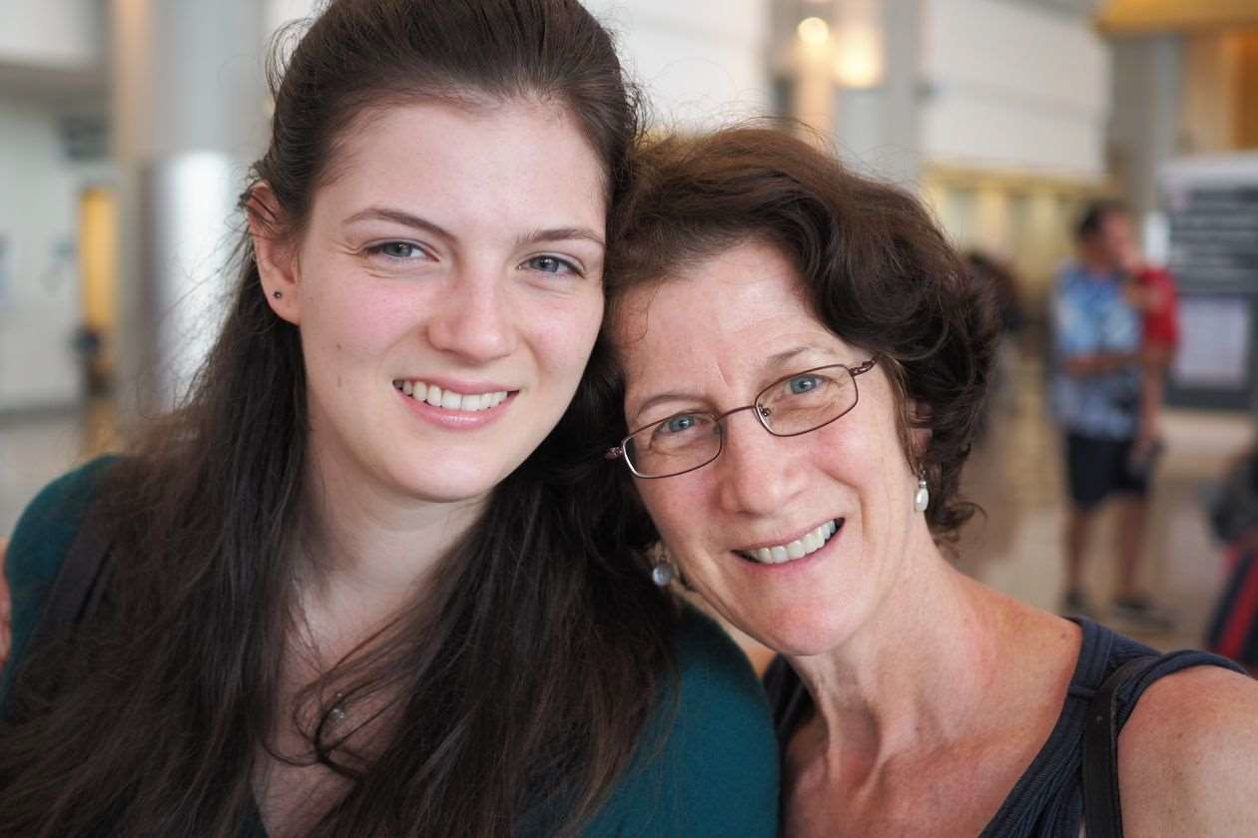His mother, Hannah Roveto of Duxbury, believes the stories helped instill a sense of adventure. "They show you don't have to do what everybody else is expecting of you, "she says. "You can do something a little crazy and still get back on a path of your own choosing."

Hannah Rose Blakeley, left ,and her mother, Cynthia, say they took valuable life lessons from family stories told at holiday gatherings.

**PHOTO:**ALLENTULLOS

Inter generational stories anchor youngsters as part of a larger group, helping them develop a sense of identity. In a 2008 study, researchers at Emory quizzed 40 youngsters ages 10 to14 on 20 family-history questions, such as how their parents met or where their grandparents grew up. Those who answered more questions correctly showed, on separate assessments, less anxiety and fewer behavior problems.

Parents who include in their stories descriptions of feelings they experienced at the time, such as distress, anger or sadness, and tell how they coped with those emotions by venting, reframing or calming them, help children learn to regulate their own emotions, Dr.Fivush says. Researchers in another study asked families with 10- to 12-year-old children to reminisce about happy and negative experiences, then followed up two years later. Children whose parents explained negative emotions and how they resolved them had better social and academic skills.

Family stories also can serve as antidotes for the pressure many teens feel to get good grades, get into an elite college and land immediately on an established career path.

Cynthia Blakeley, Hannah Rose Blakeley's mother and a liberal-studies instructor at Emory, enjoys telling stories about her late mother, Shirley. A seamstress and waitress who suffered from anxiety, her mother over came personal obstacles to attend college in her 50s and embarked on a new career as a social worker from age 60 to 78." Those were the happiest 18 years of her life, "Dr. Blakeley says.

The story inspired Dr. Blakeley to set aside her teaching career while her daughter was growing up, work from home as an editor and return to teaching in her 50s. "Standing in front of a classroom for the first time in 20 years was terrifying, "Dr. Blakeley says. "But I soon realized that I absolutely love teaching."

She sometimes tells her mother's story to her students, saying, "Don't feel too stressed outify our career trajectory isn't a straight shot."

It's the season when adults might want to think about stories they would like younger family members to know, Dr .Fivush says. "Telling a story might seem weird on a Monday at 3p.m., but over Thanksgiving dinner, it can be easier to say, 'You know, I've been thinking about a story... '"she says. A good place to start is to ask yourself, "If I had to leave the children with one or two stories, what are the ones I would want them to know?"

**Write to:** Sue Shellenbargerat[sue.shellenbarger@wsj.com](mailto:sue.shellenbarger@wsj.com)

Copyright©2019DowJones&Company,Inc.AllRightsReserved